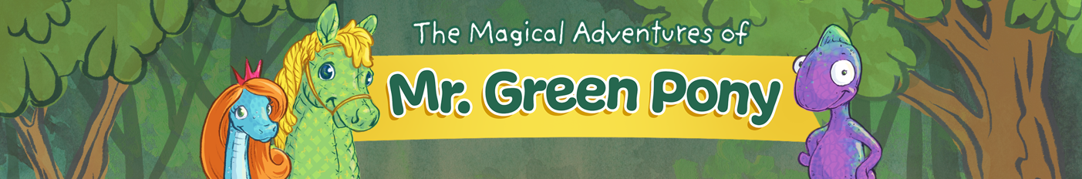

Pre-School/Early Childhood Programs
JOIN THE MR. GREEN PONY FAMILY!
The Program: The Magical Adventures of Mr. Green Pony is a series of engaging, pre-school audio stories. With fun sound effects & songs, the stories can hold a child’s attention and serve as a great alternative to screens. (Adults can also listen along to enhance a child’s learning and attention skills if they become distracted.) Each story includes educational activities that promote listening, memory and creativity as well as connecting children to nature.
The Messages: Be Kind! Be Brave! Be Green! Through friendship with nature, Mr. Green Pony and his companions take magical adventures as they learn how to be kind, brave and green. Little ones will meet the moon owl, a flying jellyfish and a royal reptile, the Princess Snake!
*Recommended for ages 2-5 yrs. (but babies and older kids have enjoyed!)
WHY the Mr. Green Pony program?
- Encourages Imagination
- Screen-free, Active Learning
- Promotes Listening & Memory
- Positive messages about KINDNESS, BRAVERY AND NATURE
- Promotes the growing brain
$125 ---What you get:
- Mr. Green Pony Story-time with Grammy Lisa’s interactive felt board. For pre-school age children. Or, a 30 minute talk with pre-k staff on screens and the growing brain. (Additional training available on how to approach families about screen-time.)
- Screen Free Tip Sheet for Parents: Includes creative ways to grow your child’s imagination, screen-free activity ideas and “Grammy Lisa’s Messages for Kids” (e.g. how to help a child deal with emotions, be kind, be brave)
- All 10 original audio stories - unlimited access for your site to use either digitally or on CD.
- 10 Educational Activities that accompany each story (printable PDF files or read off screen) Includes memory game, story discussion questions, nature activities and coloring pages! (6 pages for each story)

More info: contact Grammy Lisa at mrgreenpony@gmail.com
Or call 612 250 7859

